
Title Of The Extended Abstract For The Biomolecules Conference
First Author¹, Second Author², Third Author³
¹Affiliation 1, City, Country | ²Affiliation 2, City, Country | ³Affiliation 3, City, Country
Correspondence: corresponding.author@email.com

Introduction & Objectives

Introduce the scientific context and rationale. Clearly state your objective(s). Mention relevant literature briefly.

Materials And Methods

Provide sufficient detail to allow reproducibility. Describe materials, experimental setup, and analysis methods. Use subheadings if necessary.

Results And Discussion

Present your results and interpret them. Support findings with figures and tables (refer to them in the text). Discuss your results in the context of existing literature.

Figures and Tables

Figure captions should be placed below the image and numbered sequentially. Each figure must be referenced in the main text.

Table titles should be placed above the table and also numbered sequentially. Be sure to reference each table within the text.

See the examples of a table and a figure.

Table 1: Table title should be placed above the table
Table Head | Table Column Head
Table Head | Table column subhead | Subhead | Subhead
copy | More table copy

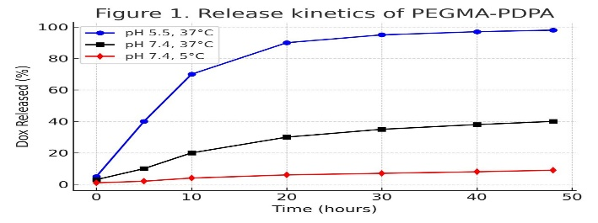
Figure 1. Figure caption should be placed below the image

Conclusions & Perspectives

Summarize key findings and their implications. Briefly discuss future research directions or applications.

References
- Smith J., et al. Title of paper. Journal Name. Volume, Pages (Year).
- Lee A., et al. Title. Conference Proceedings. City, Pages (Year).

Acknowledgment And Full Address (Optional)

Acknowledge any financial support, institutional backing, or collaborative contributions. Specify grant numbers, funding agencies, and project names when applicable. Provide the full postal address of the main institution. Indicate the corresponding author’s name and email address.

Formatting Note:

Please use Times New Roman font throughout your

document.

• Headings: Font size 11, bold

• Body text: Font size 10, justified

Please ensure that your Extended Abstract does not exceed 3 pages, including figures and references.

Once completed, please send your Extended Abstract to: biomolecules-contact@univ-lorraine.fr

